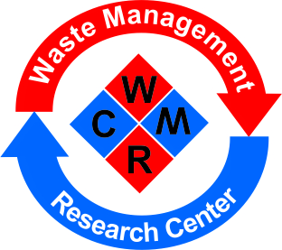
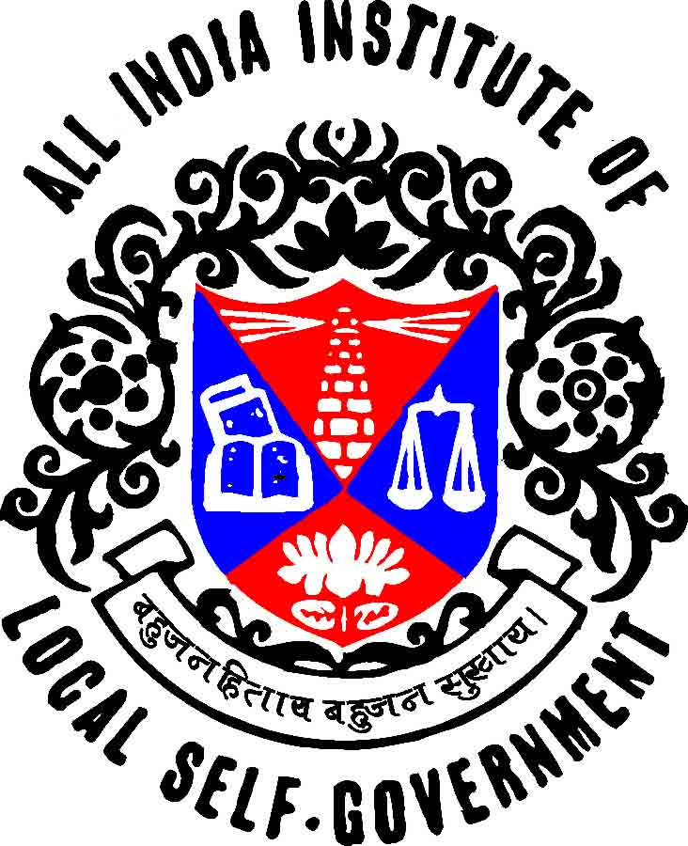

All India Institute of Local Self-Government, Mumbai
Waste Management & Research Centre [WMRC]
[Established by Government of Maharashtra
vide its GR No. SWM 2011 /Sr. No.467/ WS22, dt. 3rd September, 2011.]

Introduction -
In the year 2002, Water Supply and Sanitation Department, Government of Maharashtra established 'Solid Waste Management Cell in AIILSG, Mumbai. The SWM Cell in the light of MSW Rules, 2000 by Ministry of Environment and Forests, Government of India has done comprehensive work of technical advisory services and capacity building in Solid Waste Management field for ULBs in Maharasthtra.
Based on the backdrop of achievements of SWM Cell, the Government of Maharashtra, Water Supply and Sanitation Department established Waste Management and Research Centre [WMRC] at AIILSG, Mumbai vide its GR No. SWM 2011 /Sr. No.467/ WS22, dt. 3rd September, 2011.
The Vision of WMRC is to be a nodal institution to provide information, training and technical guidance to ULB’s to achieve improved environmental standards and to meet Service-level Benchmarks as per the Government of India indicators and regulations. In the light of Swachh Bharat Mission (SBM) and Implementation of SWM Rules, 2016 by Ministry of Environment and Forest and Climate Change, Government of India, the role of the WMRC is going to be complementary and crucial for Urban Local Bodies.
As per GR No. SWM 2011 /Sr. No.467/ WS22, dt. 3rd September, 2011, the Executive Committee is formed to monitor the work activities of WMRC under the chairmanship of Chief Secretary, Government of Maharashtra.
WMRC undertakes the following Tasks :

- Urban Policy Research.
- Tailored Training and Capacity Building Programmes for ULBs and Gram Panchayat.
- Project Management and Social Auditing.
- Information, Education and Communication [IEC] in Urban and Rural Sector.
- Training of Trainers [TOT] in Urban Services Management.
- Technical Advisory Services in the Water Supply, Sanitation and Solid Waste Management.
- Study Visits for ULBs for Experience Sharing and Cross Learning related to Solid Waste Management and Sanitation.
- Community Based Interventions in Solid Waste Management and Sanitation.
- Human Resources Development.
- Interdisciplinary Programmes.
- Knowledge Management Activities.
- Networking
- Dissemination
- Socio – Economic Surveys
- Research Projects on different Thematic Areas in Urban and Rural Sector.

Solid Waste Management :

- Capacity Building Programmes on Integrated Solid Waste Management Rules, 2016 and Sanitation for Municipal Elected Members and Municipal Officials.
- Capacity Building Programmes on Bio Medical Waste Management.
- Seminars / Workshops on Solid Waste/ Bio Medical Waste and Plastic Waste Management.
- Preparation of Status Report on Solid /Bio Medical Waste Management.
- Preparation of Operational Manuals on Solid Waste Management (based on the SWM Rules, 2016).
- Conduct Surveys supportive to Preparation of DPR, City Sanitation Plans and Time and Motion Studies.
- Preparation of DPR on Solid Waste Management for Urban Local Bodies.
- Develop Project for Solid Waste Management Segregation of Waste, Decentralized Waste Management through Community Structures and Livelihood opportunities.
- Strengthen Advance Locality Management Mechanism through People's Participation for Clean Cities Programme.
- Skill Development and Livelihood Generation through Recycling of Waste and its Bye-products.
- Awareness Programmes in Schools and Communities on Segregation of Waste and Reuse of Waste.
- Community Engagement Process and Community-Based Interventions in Solid Waste Management and Sanitation.
- Information, Education and Communication [IEC] Activities for Solid Waste Management.
- Preparation of Bye-laws on Solid Waste Management (based on SWM Rules, 2016)

Sanitation
- Preparation of Environmental Status Report for Urban Local Bodies
- Environmental Sanitation Programmes for Schools.
- Preparation of Plan for ODF Cities and required measures.
- Capacity Building Activities required for Implementation of Swachh Bharat Mission
- Forming Community Based Groups for O & M for Sanitation Facilities at Community Level.

Water Supply Management
- Preparation of DPR for Water Supply Management
- Preparation of Operation Manual for O & M in Water Supply Management
- Planning and Design of continuous Water Supply (24/7)
- Consumer Survey required for 24/7 Water Supply
- Creation of GIS based base maps –satellite image, digitization of various features like roads, buildings, water bodies etc.
- Identification of gaps between present water infrastructure and future needs as per benchmarks of MoUD, Govt. of India.
- Water Audit and Strategy for Reduction of NRW which is inevitable task of 24/7 Water Supply
- Strategic Building Blocks for 24/7 water supply such as optimum boundary for operational zones and DMA Methodology.
- Control of Physical Leaks- Pressure Management, automation /SCADA.
- Trainings on Water Supply Management and Leak Detection for ULBs.

WMRC - Key Assignments :

- Awareness Programmes on Segregation of Waste and Decentralized Waste Management for Housing Societies and Communities.
- Orientation Training on Solid Waste Management Rules, 2016 in 6 Divisions of Maharashtra with assistance of Maharashtra Pollution Control Board.
- Decentralized Waste Management System for Yashodhan and Belheaven Housing Society in Mumbai with assistance of Maharashtra Pollution Control Board.
- Study of Manpower Requirement on Refuse Vehicles of SWM Department of Municipal Corporation of Greater Mumbai for Waste Collection and Loading of the Waste.
- Scrutiny of draft RFP document for “Door to Door Collection and Transportation of Segregated Municipal Solid Waste of Nagpur Municipal Corporation.
- NIUA selected WMRC, as a Training Entity to conduct a series of SBM-SWM Exposure workshops in 43 locations in Gujarat and Maharashtra State and UTs for the officials working in SWM Department of ULBs. The said assignment was supported by Ministry of Housing and Urban Affairs, Government of India. Accordingly, WMRC successfully conducted total 8 workshops - 2 workshops in Ahmedabad, 2 in Surat, 1 in Silvassa, 1 in Nashik, 1 in Mumbai and 1 in Nagpur.
- Pilot Project - Solid and Liquid Waste Management for Rural Areas- Vandre and Nagaon in Thane District supported by Water Supply & Sanitation Department, Government of Maharashtra
- Organization of Training Programmes on Integrated Solid Waste Management (with special reference to SWM Rules, 2016) for Elected Members and Municipal Officials from different States.
- Preparation of Operational Reference Book Manual for Solid Waste Management (based on the SWM Rules, 2016).
- Specialized Training Programmes on Bio-Medical Waste Handling.
- Preparation of DPR related to SWM for selected cities.
- Preparation of Status Report on Solid Waste Management for ULBs in Maharashtra.
- Project for Segregation of Waste, Decentralized Processing through Community Structures and Livelihood Generation.
- Preparation of Environmental Status Report for Municipal Corporations and ‘A’ Class Municipal Councils.
- Environmental Sanitation Pprogrammes for Schools.
- Legal Framework - Preparation of Bye-laws for SWM and Waste Water. Recycling and Reuse.
- Information, Education and Communication [IEC] Material for Environment, Planning and Management (EPM) for Swachh Bharat Mission.
- School Sanitation & Environment Management in 9 Wards of Navi Mumbai Municipal Corporation.
- Third Party Audit of 38 Wards of the Nagpur Municipal Corporation under Swachh Maharashtra Abhiyan, Ward Competition

Contact :
Dr. (Prof.) Sneha Palnitkar
Chief Executive Officer
Waste Management & Research Centre
All India Institute of Local Self-Government,
11/13, Botawala Building, 3rd Floor,
Horniman Circle, Opp. Town Hall,
Fort, Mumbai – 400 001.
Tel. No. (022) 22661910 / 2957
Email :ceo.aiilsg@gmail.com / snehapalnitkar@gmail.com

*****

